Task 1



Task 2

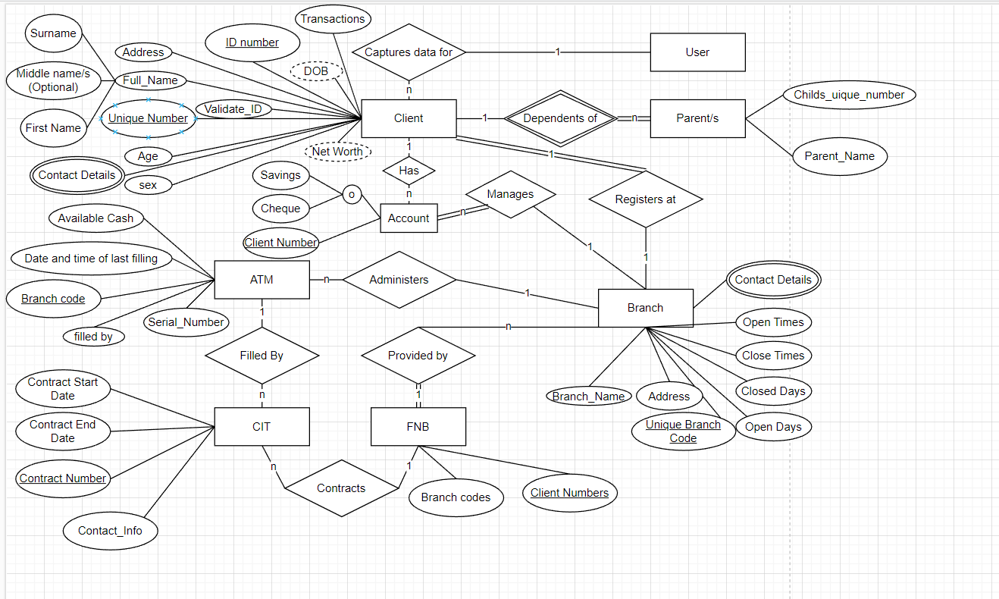

Task 3

Step 1: Mapping of Regular Entity Types Creating relations for each strong entity type.

Step 2: Mapping of Weak Entity Types Adding in relations for each weak entity type.

Step 3: Mapping of Binary 1:1 Relationship Types Creating links between all the 1:1 relationships.

Step 4: Mapping of Binary 1:N Relationship Types.

Step 5: Mapping of Binary M:N Relationship Types. My modal has no M:N relations. Step 6: Mapping of Multivalued Attributes. Names is split up into Fname, Mname and Lname.

Step 7

Task 4

Account:

ATM:

Branch:

CIT:

Clients:

FNB:

Parents:

Task 5

5.1: **SELECT** Full_Name, DOB, Address, Sex

**FROM** clients

5.2: **DROP EXTENSION** Unique_Branch_Code

**WHERE** Unique_Branch_Code = 1;

5.3: **SELECT** *

**FROM** clients

**WHERE** Validate_ID = 0

5.4: **UPDATE** ATM

**SET** Branch_Code = 2

**WHERE** Branch_Code = 1;

Task 6

6.1: σ(Serial_Number like 'ABC123%') (atm)

6.2: Concat 🡨 CIT U ATM

From that

π (Contact_Info)(Branch_Code = 3)(Concat)

6.3:

π(Full_Name, Contact_Details)(Transactions_per_year > 24)(Clients)

Task 7

Please refer to the file for SQL dump.